Experiment: 9 Massive MIMO Capacity vs SNR and Gain Using MATLAB

Objective – 1
MATLAB Code:
clc;
clear;
close all;
snr = 0:5:30;
snr_linear = 10.^(snr/10);
capacity = log2(1 + snr_linear);
figure;
plot(snr,capacity,'-o','LineWidth',2,'MarkerSize',6);
grid on;
xlabel('SNR (dB)');
ylabel('Channel Capacity (bps/Hz)');
title('Channel Capacity vs SNR');

OUTPUT:
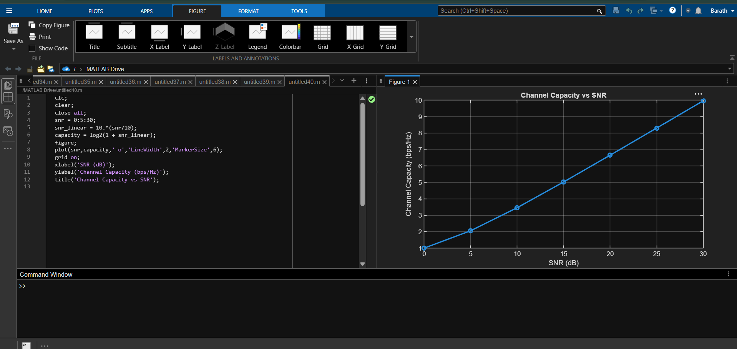

Objective – 2
MATLAB Code:
clc;
clear;
close all;
snr = 0:5:30;
snr_linear = 10.^(snr/10);
capacity = log2(1 + snr_linear);
figure;
plot(snr,capacity,'-o','LineWidth',2,'MarkerSize',6);
grid on;
xlabel('SNR (dB)');
ylabel('Channel Capacity (bps/Hz)');
title('Channel Capacity vs SNR');

OUTPUT:
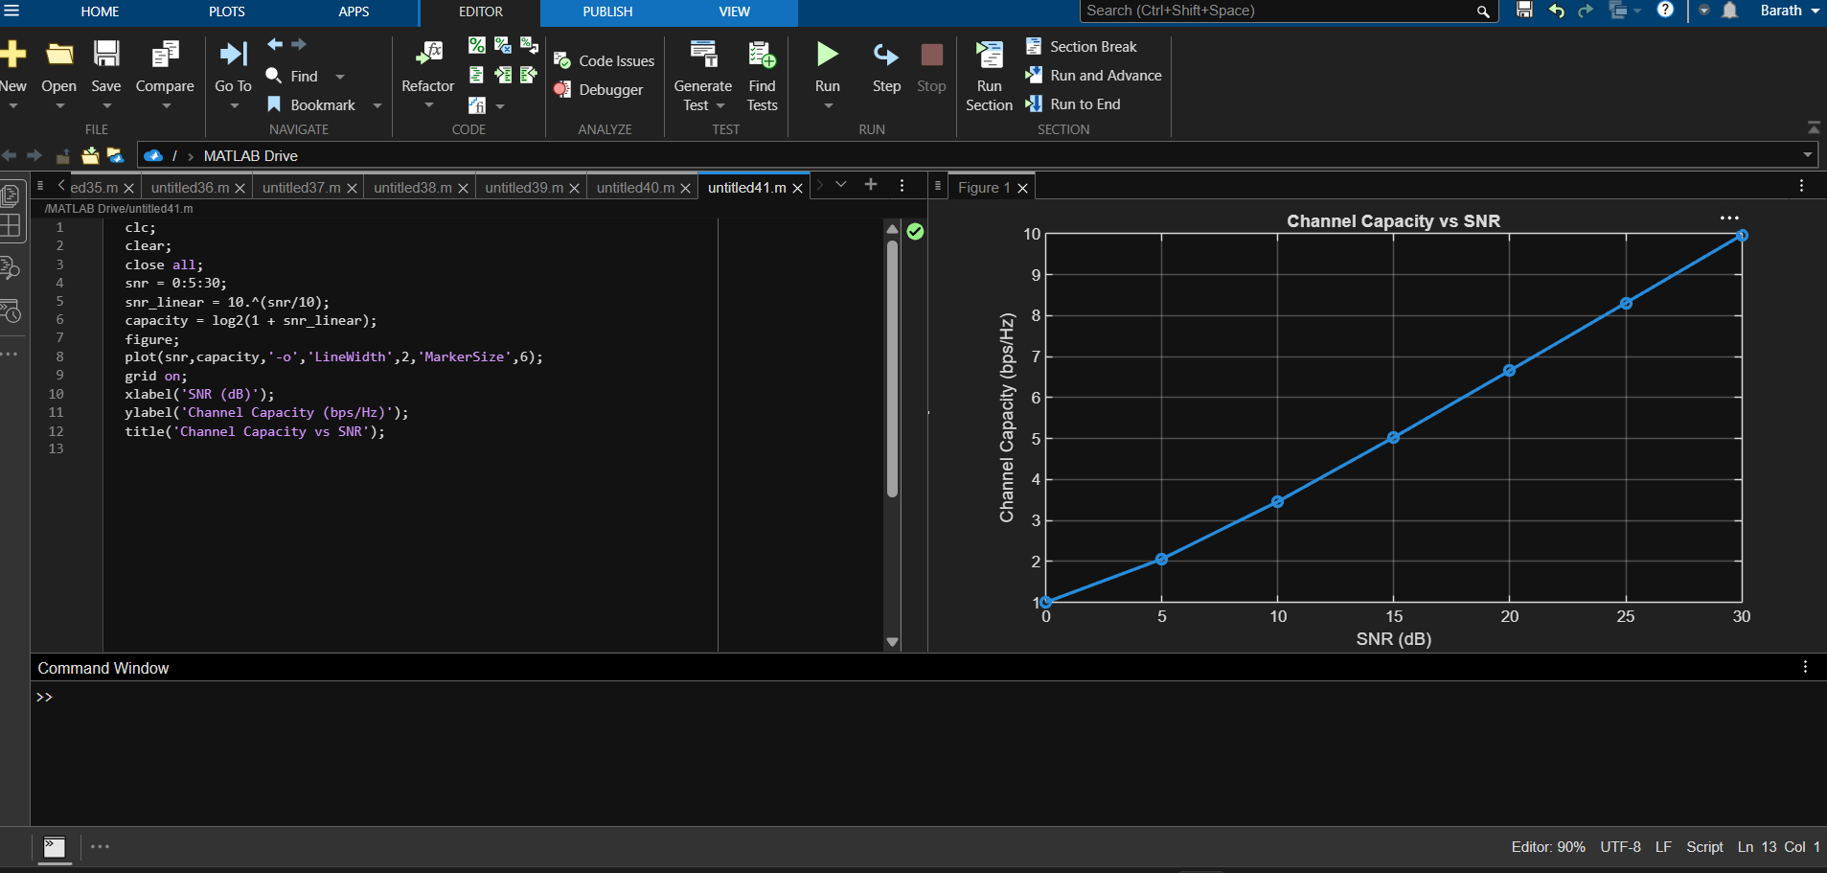
Objective – 3
MATLAB Code:
clc;
clear;
close all;
antennas = [4 8 16 32 64];
gain = 10*log10(antennas);
figure
bar(antennas, gain)
grid on
% Number of Antenna Elements
% Antenna Gain (dB)
xlabel('Number of Antenna Elements')
ylabel('Antenna Gain (dB)')
title('Antenna Gain for Different Antenna Array Sizes')

OUTPUT:
